Jason Bausch
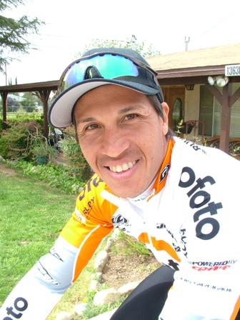 |  | DOB: 06.17.68  Nationality: American  Hometown: Huntington Beach, CA  Residence: Huntington Beach, CA  Email: bausch@yahoo.com
A new member of the Ofoto / Lombard’s Cycling team this year, Jason brings a vast amount of enthusiasm as well as maturity and professionalism. A former professional surfer and US National team member on the mountain bike, Jason has a large amount of untapped talent and had a great year showcasing his ability on and off the bike. Always willing to assist in any way by winnings races or providing support at community events, Boys and Girls Clubs, schools for its sponsors.
Career Highlights:
2004 July 26 - August 1 - Tour de Toona; Altoona, PA
Crown American/Cambria CVB Road Race
2 Jason Bausch
Martinsburg Road Race
2 Jason Bausch
Current Points leaders SoCal Riders Cup Championship http://www.socalcycling.com/uscf/RidersCup/2004/details2.asp?B0078109
- 2nd - Semena Mautica Classic
4th - GC Vuelta a Valencia
6th - Stage 3 Pomona Valley Stage Race
6th - Superweek International, Humbolt Park
- 1st Fiesta Island State Championships Team Time Trial
5st Pomona Valley Stage Race
- 3rd Las Vegas Stage Race
- 1st Coupe Des Ameriques Time Trial
3rd Coupe Des Ameriques Stage Race
Interview Topics:
  - Hometown, Years Professional, Local Sponsor Ofoto
  - Nutrition: Weight/ Body Fat 5%, Calories used during the race 10k
  - Race Strategies Ofoto Aggressive & Attentive while being respected
  - Results 2004, Expectations/ Role for T-Mobile race
  - Next Year plan / off season training plans, Hobbies, Family

